Sleep and stress Analysis

1. Introduction
Sleep Stress and Analysis is a data analysis project that examines the relationship between sleep patterns, lifestyle habits, and stress levels.
The dataset contains responses from individuals regarding their sleep duration, sleep quality, bedtime, screen usage, exercise frequency, sources of stress, and other sleep-related habits.
SQL queries were performed using My SQL Workbench to analyze the dataset and identify patterns in average stress levels across different categories.
The project aims to understand how different sleep and lifestyle factors are associated with variations in reported stress levels.

2. Objectives
The main objectives of this project are:
- To analyze the overall stress level of the respondents.
- To examine stress levels based on sleep duration.
- To analyze the relationship between sleep quality and stress.
- To compare stress levels based on bedtime.
- To analyze the effect of screen usage on stress levels.
- To examine stress levels according to exercise frequency.
- To identify the major sources of stress.
- To analyze how frequently respondents feel stressed.
- To examine the relationship between waking up during the night and stress.
- To analyze whether respondents use electronic devices before sleeping.

3. Tools and Technologies Used
Tool / Technology | Purpose
MySQL | Storing and analyzing the dataset using SQL
MySQL Workbench | Writing and executing SQL queries
Microsoft Excel | Creating Pivot Tables and charts for data visualization
SQL | Data aggregation, grouping, and analysis

4. Dataset Overview
The dataset contains 38 responses.
The table used for analysis is:
Untitled form
Important columns include:
- Age
- Gender
- Occupation
- Sleep Hours
- Bed Time
- Sleep Quality Rate
- Stress Level Rate
- Wake Up During the Night
- Screen Hours
- Using Devices Before Sleep
- Exercises in a Week
- Feeling Stressed During Typical Week
- Main Source of Stress

5. Total Number of Responses

Objective
To determine the total number of responses available in the dataset.

SQL Query

SELECT COUNT(*) AS Total_response
FROM `untitled form`;

Result
Total responses = 38

Description
The COUNT(*) function counts the total number of records available in the table. The query returned 38, indicating that the dataset contains responses from 38 participants.

Interpretation
The analysis is based on a total of 38 survey responses.
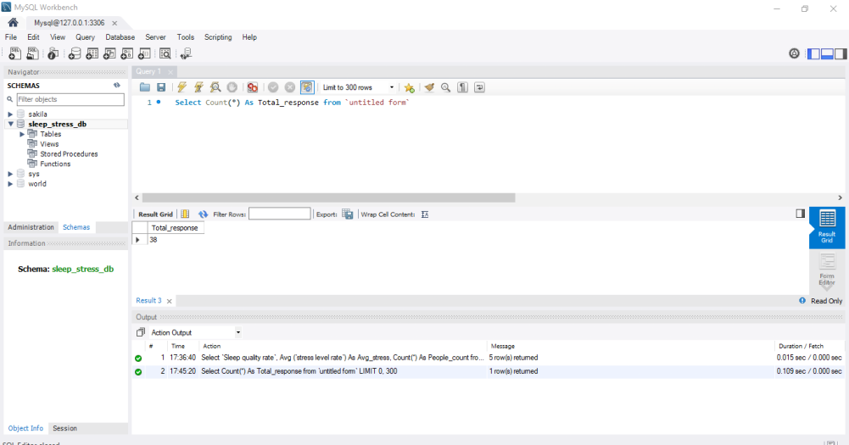

6. Average Stress Level

Objective
To calculate the overall average stress level among the respondents.

SQL Query
Select Avg (`Stress level rate`) As avg_stress from `untitled form`

Result
Average stress level = 6.0526

Description
The AVG() function calculates the mean value of the Stress level rate column.

Interpretation
The overall average reported stress level among the 38 respondents is approximately 6.05.
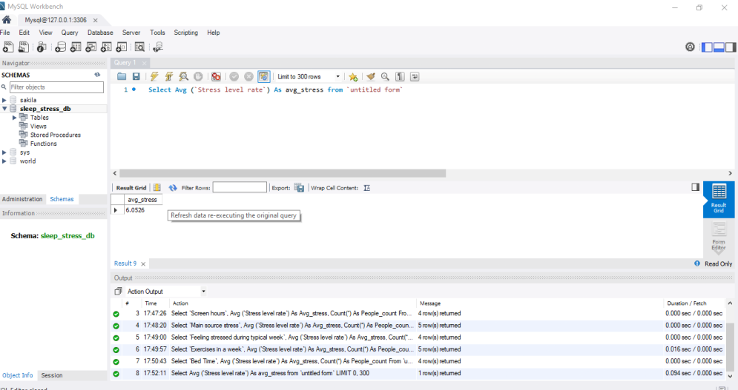

7. Sleep Hours vs Average Stress Level

Objective
To analyze how average stress levels vary according to the number of hours respondents sleep.

SQL Query
SELECT `Sleep Hours`,
AVG(`Stress level rate`) AS Avg_stress,
COUNT(*) AS People_count
FROM `untitled form`
GROUP BY `Sleep Hours`;

Results
Sleep Hours | Average Stress | People
5–6 | 7.1250 | 8
6–7 | 5.5000 | 12
7–8 | 6.3125 | 16
More than 8 | 3.0000 | 2

Description
The query groups respondents according to their sleep duration and calculates both the average stress level and number of people in each group.

Chart Title: Sleep hours vs stress level
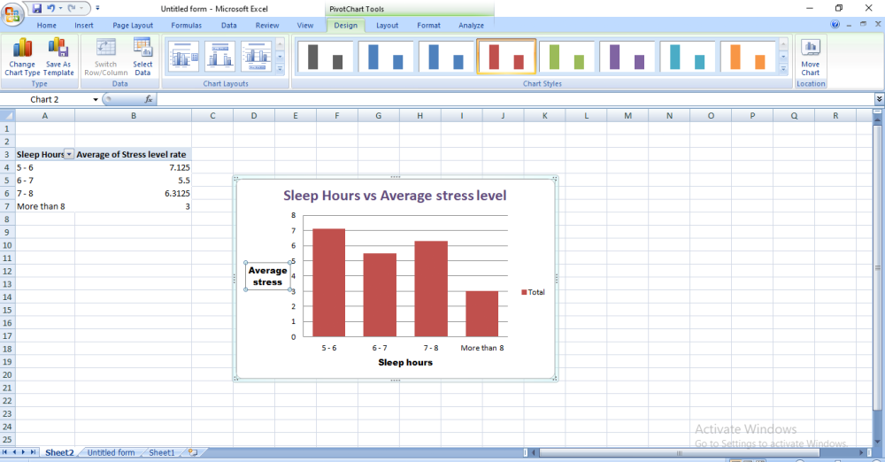
Description:
This chart compares respondents' average stress levels according to the number of hours they sleep. Respondents who sleep for 5–6 hours have the highest average stress level of 7.13, while those who sleep for more than 8 hours have the lowest average stress level of 3.00. Respondents who sleep for 7–8 hours have an average stress level of 6.31, while those who sleep for 6–7 hours have an average of 5.50. The results indicate differences in reported stress levels across sleep-duration categories.

Interpretation
The 5–6 hour sleep group has a relatively high average stress level of 7.1250. The 7–8 hour group, which contains the largest number of respondents, has an average stress level of 6.3125.
The more-than-8-hour group has the lowest average stress level at 3.00, but it contains only 2 respondents, so this result should not be treated as a strong general conclusion.
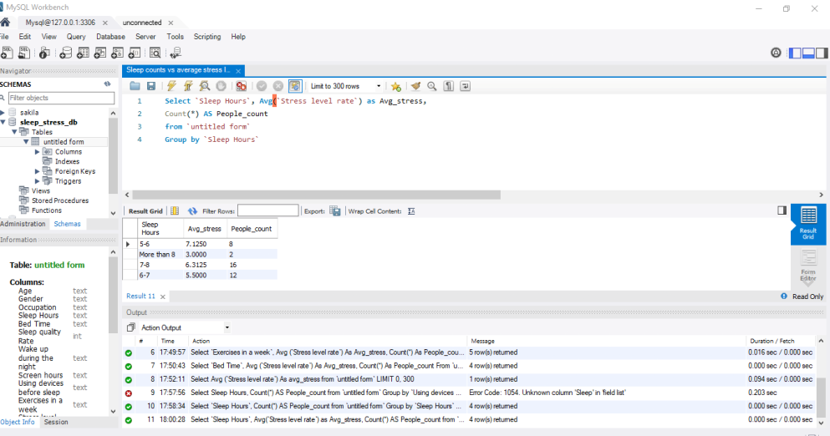

8. Sleep Hours vs Number of People

Objective
To understand how respondents are distributed across different sleep-duration categories.

SQL Query

SELECT `Sleep Hours`,
COUNT(*) AS People_count
FROM `untitled form`
GROUP BY `Sleep Hours`;

Results
Sleep Hours | Number of People
5–6 | 8
More than 8 | 2
7–8 | 16
6–7 | 12

Interpretation
The 7–8 hour category contains the largest number of respondents, with 16 people. The more-than-8-hour category contains only 2 people.
This indicates that most respondents in this dataset reported sleeping between 6 and 8 hours.
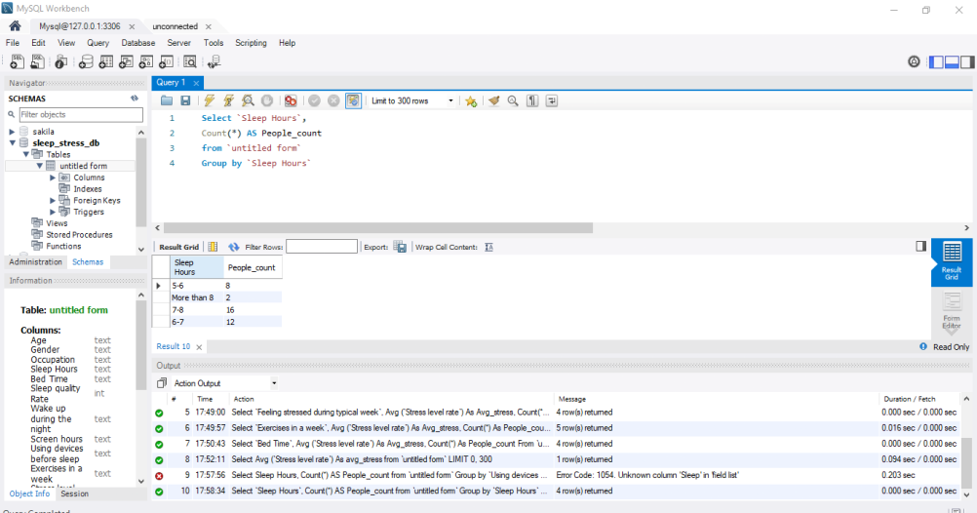

9. Sleep Quality vs Average Stress Level

Objective
To examine whether average stress levels differ according to sleep quality ratings.

SQL Query
Select `Sleep quality rate`, Avg (`stress level rate`) As Avg_stress,
Count(*) As People_count
from `untitled form`
Group by `Sleep quality rate`
Order by `Sleep Quality rate`

Results
Sleep Quality Rate | Average Stress | People
1 | 6.0000 | 1
2 | 6.5000 | 14
3 | 6.2308 | 13
4 | 4.8333 | 6
5 | 5.7500 | 4

Interpretation
The largest groups are ratings 2 and 3, with 14 and 13 respondents respectively.
The average stress level for sleep quality rating 4 is 4.8333, which is lower than the averages for ratings 2 and 3.
However, the relationship is not strictly linear, so the results do not show that higher sleep quality automatically corresponds to lower stress in this dataset.
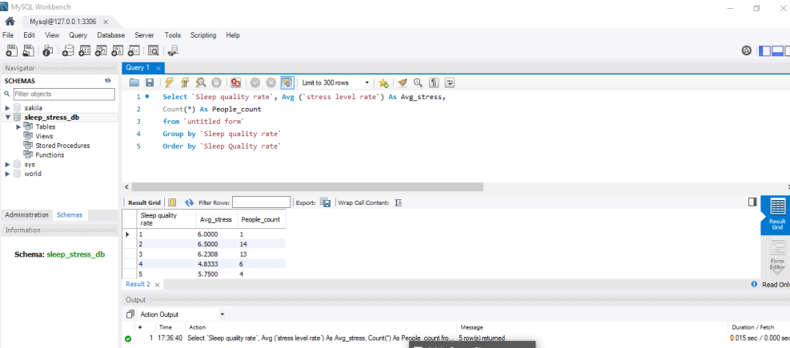

11. Bedtime vs Average Stress Level

Objective
To analyze whether average stress levels differ according to respondents' bedtime.

Sql Query
Select `Bed Time`,
Avg (`Stress level rate`) As Avg_stress, Count(*) As People_count
From `untitled form`
Group by `Bed Time`

Results
Bed Time | Average Stress | People
Before 10 PM | 5.1667 | 6
10–11 PM | 5.5000 | 6
11 PM–12 AM | 6.3529 | 17
After 12 AM | 6.4444 | 9

Chart title: Bed Time vs Average Stress Level
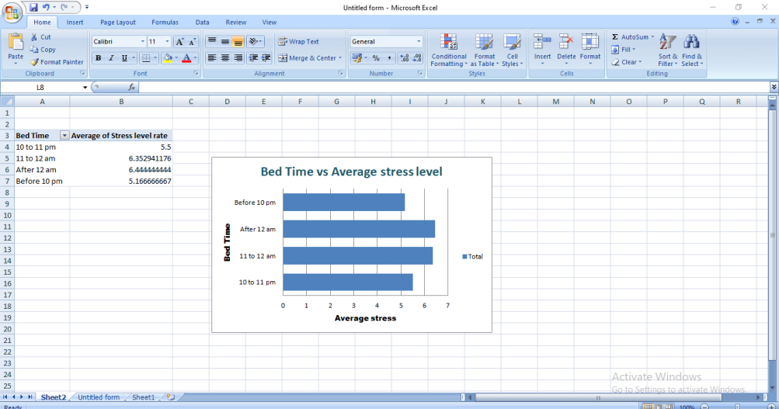
Description:
The chart shows the average stress level for respondents based on their bedtime. Respondents who go to bed after 12 AM have the highest average stress level of approximately 6.44, followed by those who sleep between 11 PM and 12 AM with an average of approximately 6.35. Respondents who go to bed before 10 PM have the lowest average stress level of approximately 5.17. This indicates that later bedtime categories are associated with higher reported stress levels in this dataset.

Interpretation
The highest average stress level is observed among respondents who go to bed after 12 AM, with an average stress level of 6.4444.
The 11 PM–12 AM category has 17 respondents and an average stress level of 6.3529.
The before 10 PM group has the lowest average stress level at 5.1667.
This dataset therefore shows an association between later bedtime categories and higher average reported stress, although this does not establish causation.
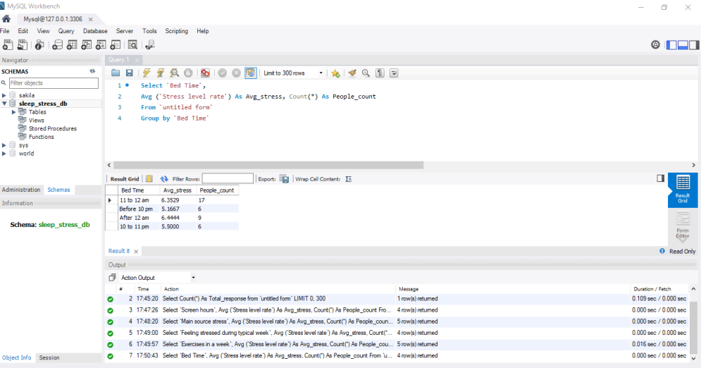

11. Exercise Frequency vs Average Stress Level

Objective
To analyze average stress levels according to the number of times respondents exercise per week.

Sql Query
Select `Exercises in a week`,
Avg (`Stress level rate`) As Avg_stress, Count(*) As People_count
From `untitled form`
Group by `Exercises in a week`

Results
Exercise Frequency | Average Stress | People
Never | 5.8667 | 15
1–2 times | 5.7000 | 10
3–4 times | 5.4000 | 5
5 times | 7.7500 | 4
Always | 6.7500 | 4

Chart title: Exercise Frequency vs Average Stress Level
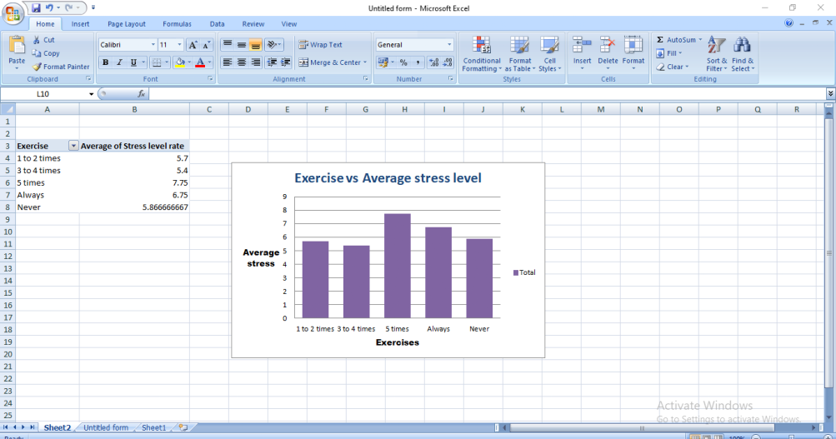
Description:
The chart compares average stress levels according to exercise frequency. Respondents who exercise 5 times per week have the highest average stress level of 7.75, while those who exercise 3 to 4 times per week have the lowest average stress level of 5.40. The results do not show a simple relationship between exercise frequency and stress, as the highest exercise category does not have the lowest stress level.

Interpretation
The 5-times-per-week group has the highest average stress level at 7.75.
The 3–4 times per week group has the lowest average stress level at 5.40.
However, the groups exercising 5 times or always contain only 4 respondents each, so these higher averages should be interpreted cautiously.
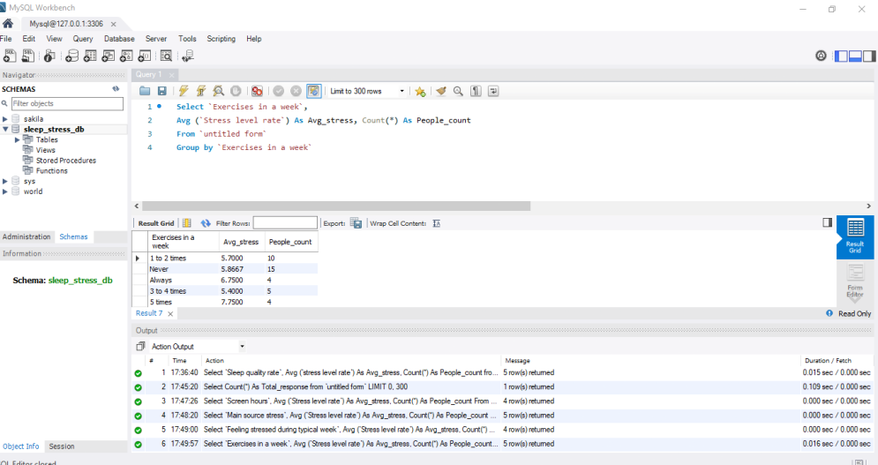

12. Feeling Stressed During a Typical Week

Objective
To compare average stress levels according to how frequently respondents report feeling stressed during a typical week.

Sql Query
Select `Feeling stressed during typical week`,
Avg (`Stress level rate`) As Avg_stress, Count(*) As People_count
From `untitled form`
Group by `Feeling stressed during typical week`

Results
Frequency | Average Stress | People
Rarely | 5.0000 | 9
Sometimes | 6.1765 | 17
Often | 7.1818 | 11
Never | 1.0000 | 1

Interpretation
Respondents who reported feeling stressed often had an average stress level of 7.1818, which was the highest among the larger groups.
Those who reported feeling stressed rarely had an average of 5.00.
The "Never" category has an average of 1.00, but it represents only one respondent, so it cannot be used as a reliable comparison group.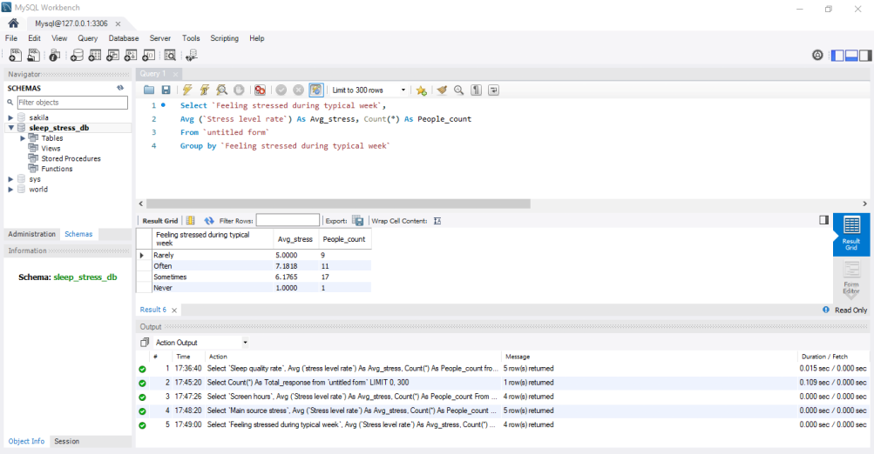

13. Main Source of Stress

Objective
To identify the major sources of stress and compare their average stress levels.

Sql Query
Select `Main source stress`,
Avg (`Stress level rate`) As Avg_stress, Count(*) As People_count
From `untitled form`
Group by `Main source stress`

Results
Main Source | Average Stress | People
Work | 5.9412 | 17
Family | 7.0000 | 4
Health | 5.6667 | 3
Financial Issues | 6.0769 | 13
Studies | 5.0000 | 1

Chart title: Main Source of Stress vs Average Stress Level
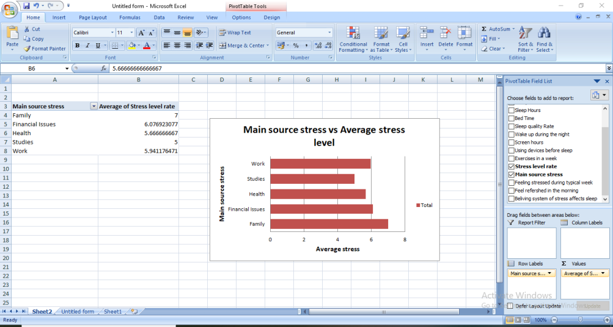
Description:
The chart compares average stress levels according to the main source of stress reported by respondents. The Family category has the highest average stress level at 7.00, followed by Financial Issues at approximately 6.08. The Studies category has the lowest average stress level at 5.00. However, the Studies category contains only one respondent, so its value should be interpreted cautiously.

Interpretation
Work is the most common reported source of stress, with 17 respondents.
Financial issues are the second most common source, with 13 respondents.
The highest average stress level is observed in the Family category at 7.00, although this category contains only 4 respondents.
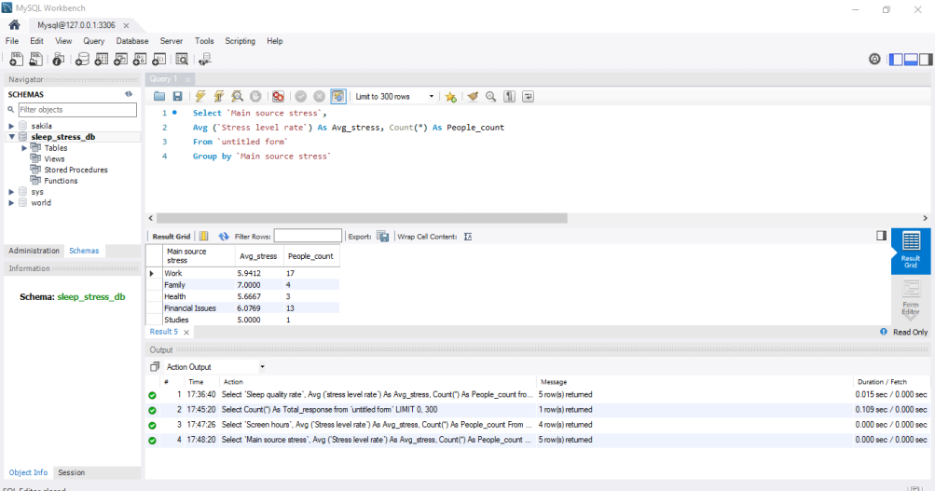

14. Screen Hours vs Average Stress

Objective
To examine differences in average stress levels based on daily screen usage.

Sql Query
Select `Screen hours`,
Avg (`Stress level rate`) As Avg_stress, Count(*) As People_count
From `untitled form`
Group by `Screen hours`

Results
Screen Hours | Average Stress | People
Less than 2 | 5.5000 | 6
2–4 | 6.6250 | 8
4–6 | 7.1667 | 6
More than 6 | 5.6111 | 18

Chart Title: Screen Hours vs Average stress level
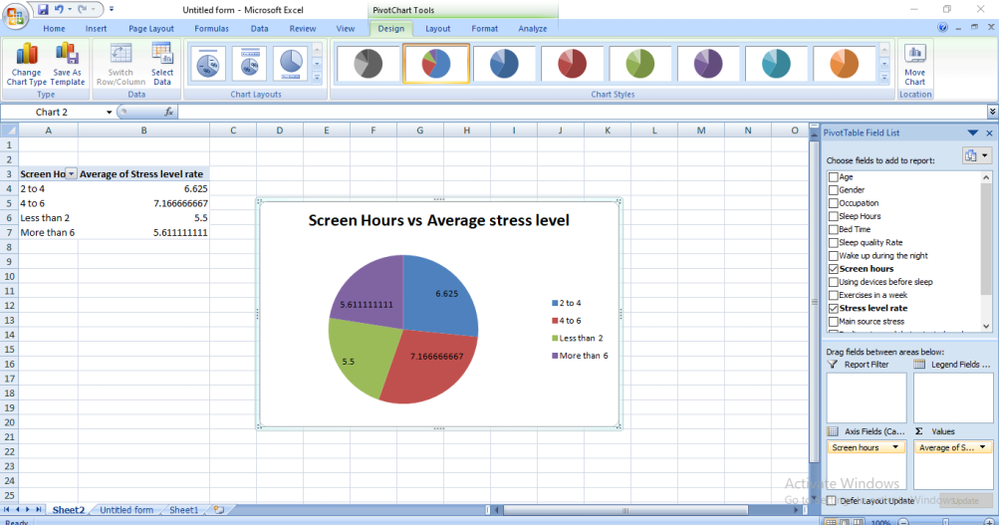
Description:
This chart illustrates the average stress levels of respondents based on their daily screen time. Respondents who spend 4–6 hours on screens have the highest average stress level of approximately 7.17, followed by those who spend 2–4 hours, with an average of 6.63. Respondents who use screens for less than 2 hours have an average stress level of 5.50, while those who spend more than 6 hours have an average of 5.61. The results show variations in stress levels across different screen-time categories. However, the findings do not establish a direct causal relationship between screen time and stress.

Interpretation
The 4–6 hour screen-time group has the highest average stress level at 7.1667.
The largest group is respondents with more than 6 hours of screen time, with 18 people, and their average stress level is 5.6111.
The results do not show a simple increasing relationship between screen time and stress.
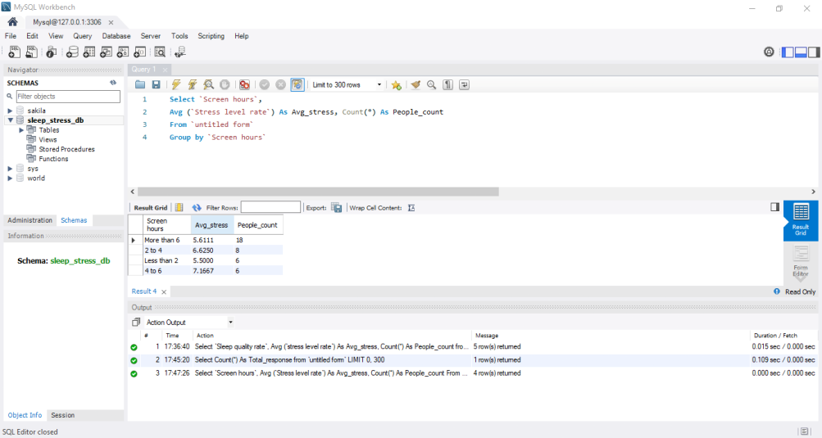

15. Using Devices Before Sleep vs Average Stress

Objective
To analyze average stress levels based on whether respondents use electronic devices before sleeping.

SQL Query
Select `Using devices before sleep`, AVG(`Stress level rate`) As avg_stress,
Count(*) AS People_count
from `untitled form`
Group by `Using devices before sleep`

Results
Device Usage | Average Stress | People
Yes | 6.1290 | 31
No | 4.8000 | 5
Maybe | 8.0000 | 2

Chart Title: Using devices before sleep vs average stress level
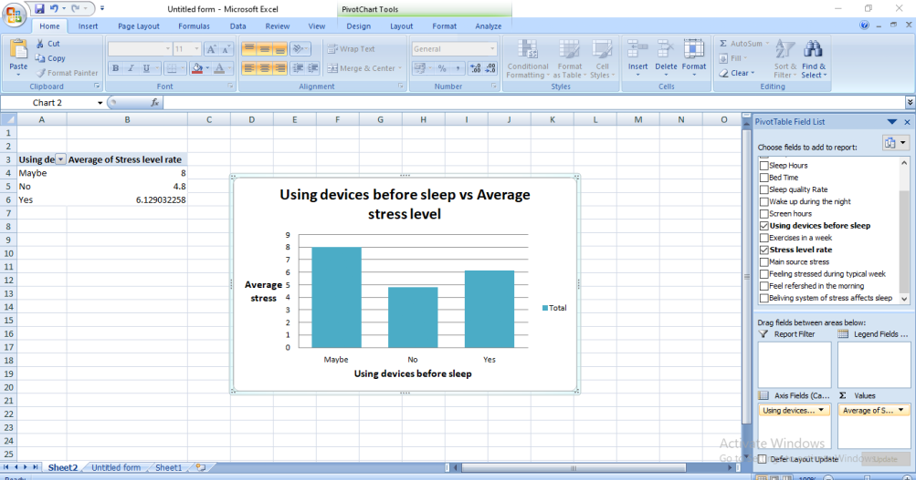
Description:
This chart compares average stress levels among respondents based on whether they use electronic devices before sleeping. Respondents who answered "Maybe" have the highest average stress level of 8.00, followed by those who answered "Yes," with an average of approximately 6.13. Respondents who answered "No" have the lowest average stress level of 4.80. These findings show differences in reported stress levels according to device usage before sleep, but they do not establish that device usage causes higher stress.

Interpretation
Most respondents (31 out of 38) reported using devices before sleep.
The "Yes" group has an average stress level of 6.1290, while the "No" group has an average of 4.80.
The "Maybe" category has the highest average of 8.00, but it contains only 2 respondents.
Therefore, the results suggest a difference in reported stress levels between device users and non-users, but the dataset is too small and observational to establish a causal relationship.
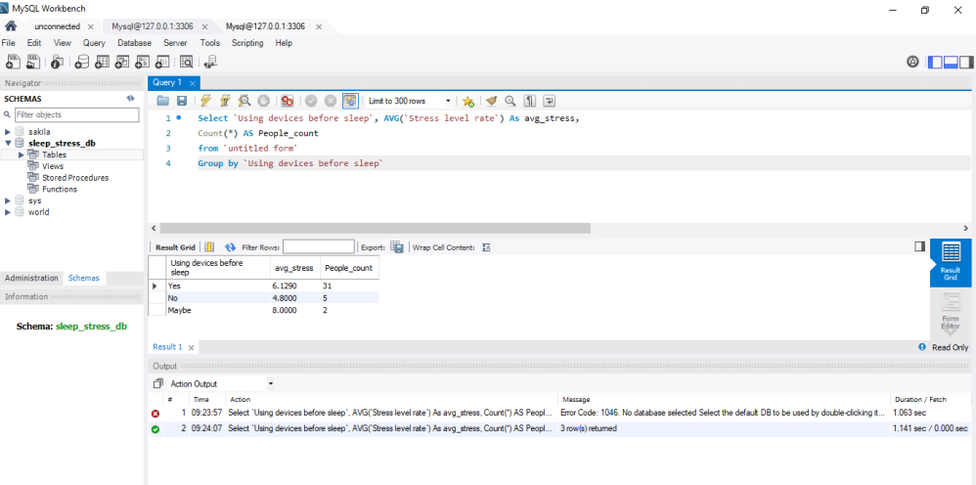

16. Waking Up During the Night vs Average Stress

Objective
To examine differences in average stress levels based on how frequently respondents wake up during the night.

Sql Query
Select `Wake up during the night`, Avg(`Stress level rate`) As Avg_Stress,
Count(*) As people_count
From `Untitled form`
Group by `Wake up during the night`

Results
Wake-up Frequency | Average Stress | People
Rarely | 5.6000 | 15
Sometimes | 5.7692 | 13
Often | 6.2500 | 4
Never | 7.6667 | 6

Interpretation
The Never category has the highest average stress level at 7.6667, followed by the Often category at 6.25.
Interestingly, respondents who reported waking up during the night "rarely" had an average stress level of 5.60.
This result does not show a straightforward relationship between night time waking and stress.
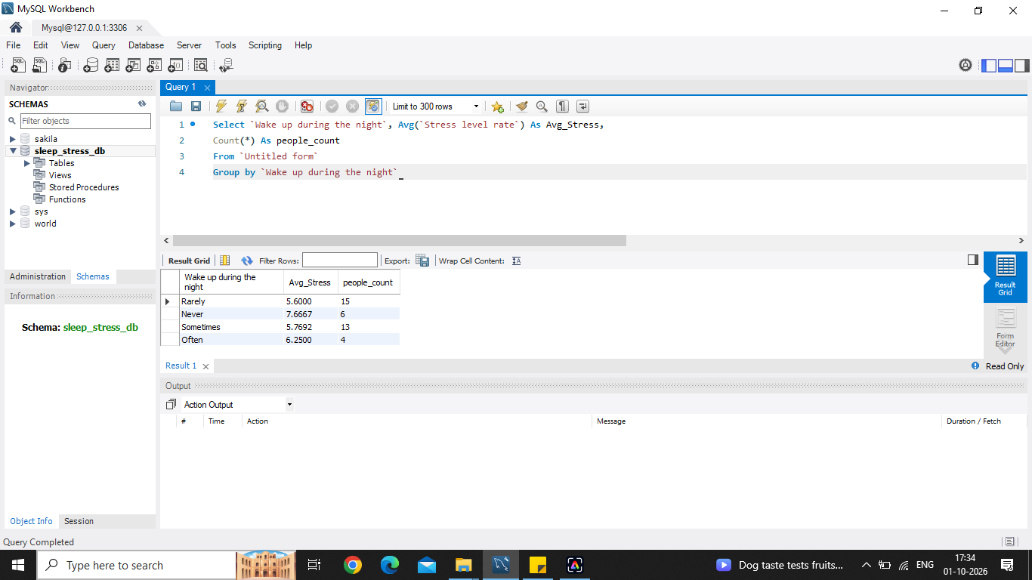

17. Key Findings
Based on the SQL analysis of 38 responses, the following observations were identified:
- The overall average stress level is 6.0526.
- The 7–8 hour sleep category contains the largest number of respondents.
- The 5–6 hour sleep group has a relatively high average stress level of 7.1250.
- Respondents going to bed after 12 AM have the highest bedtime-related average stress level at 6.4444.
- Work is the most common reported source of stress, with 17 respondents.
- Family has the highest average stress among the main stress-source categories, at 7.00, but only 4 respondents are in that group.
- Respondents who report feeling stressed often have an average stress level of 7.1818.
- The 4–6 hour screen-time group has the highest screen-time-related average stress level at 7.1667.
- Most respondents, 31 out of 38, use devices before sleeping.
- The 5-times-per-week exercise group has an average stress level of 7.75, but only 4 respondents belong to this group.
- Some categories have very small sample sizes, so their averages should be interpreted carefully.

18. Conclusion
The Sleep Stress and Analysis project demonstrates the use of SQL to analyze relationships between sleep habits, lifestyle factors, and reported stress levels.
Using MySQL, the dataset was analyzed with functions such as COUNT(), AVG(), and GROUP BY. The analysis identified differences in average stress levels across sleep duration, sleep quality, bedtime, exercise frequency, screen time, sources of stress, and other sleep-related behaviors.
The results indicate several interesting patterns, such as higher average stress among some respondents with shorter sleep durations and later bedtimes. However, the analysis is based on only 38 responses, and several categories contain very few participants. Therefore, the findings should be considered descriptive observations rather than proof of cause-and-effect relationships.
Overall, the project demonstrates how SQL can be effectively used to transform survey data into meaningful analytical insights.

19. Future Scope
The project can be further improved by:
- Increasing the number of survey responses.
- Creating visualizations using Power BI or Tableau.
- Performing correlation analysis between sleep and stress.
- Comparing stress levels across age groups and occupations.
- Creating an interactive dashboard.
- Applying statistical analysis to determine whether observed relationships are significant.
- Adding more sleep and lifestyle variables for deeper analysis.

